Olzhas Kurikov

[ok34@hw.ac.uk](mailto:ok34@hw.ac.uk)

**Resonant Ultrasound Spectroscopy**

Analysis of thickness resonances to characterise a material

Master Thesis Project

16.01.2017 – 03.07.2017

Supervisor

Prof. Marc Desmulliez

Second supervisor

Prof. Thomas Speck

Co-supervisor

Dr. Anne Bernassau

Heriot-Watt University, Edinburgh

Albert-Ludwig’s University, Freiburg

1. **Introduction**

The aim of this project was to establish reliable setup to characterise a living material using resonant ultrasound spectroscopy. In the first stage of the project, the solid materials such as aluminium, glass and plastics were tested to prove that setup is well tested and ready to switch to a living materials such as plants. The experiments were performed with aluminium, glass and plastic due to existing elastic constants, hence it is straightforward to compare datasheet values to analysed data.

The main reason why exactly ultrasound resonant spectroscopy was used is that that by measuring transmission coefficient of a sample, RUS can infer parameters like thickness, density, attenuation coefficient, speed of sound and first order resonant frequency. Moreover, this technique is non-destructive, non-invasive, rapid and relatively inexpensive. Therefore, there is no damage on a sample which is significantly important for a plant samples, while running the experiment.

Coefficient of transmission of sound at normal incidence through each sample in the frequency range 0.6 MHz – 1.7 MHz was measured. For all cases, at least one thickness resonance was observed. From these measurements density, sound velocity, and attenuation of ultrasonic longitudinal waves were obtained and compared to available data provided in an articles or by manufacturers.

The method is based on frequency-domain analysis, by using the Fast Fourier transform, of pulse transmitted through a sample.

All the experiments were conducted in Biology department of Albert-Ludwig’s University of Freiburg city in Germany. And the required equipment, except oscilloscope (listed below) were transported from Heriot-Watt University, Edinburgh:

* Transducer
* Hydrophone
* Water tank
* Pulser/receiver
* DC coupler
* Oscilloscope

Results reveal that these resonances are strongly sensitive on different parameter changes which are discussed further in the report.

This report goes through all the steps and problems which are faced during the experiments and gives suggestions for further improvements.

1. **Literature review and theory**
   1. **Fundamentals of ultrasound**

**2.1.1 Ultrasound**

The sound waves with frequencies above 20 kHz is called ultrasound and they are not in range for human hearing (William, 2012). Ultrasound is broadly used technique in different applications of medicine, food industry, factories and non-destructive testing. Sending and receiving of transmitted or reflected ultrasonic pulses allows ultrasonic devices to detect objects, defects and measure distances.

Ultrasound imaging (sonography) is mostly used in medicine to identify a health or gender of baby. In the non-destructive testing of materials or structures, ultrasonic waves are used to detect flaws. Industrially, ultrasound is used for cleaning, mixing and to accelerate chemical processes. In living environment, animals like bat and porpoises use ultrasound to locate prey and obstacles.

Table I. Frequency classification of Ultrasound

|  |
| --- |
| Frequency (Hz) Classification |
| 20 – 20.000 Audible sound  20.000 – 1.000.000 Ultrasound  1.000.000 – 30.000.000 Diagnostic ultrasound |

**2.1.2 Ultrasonic waves**

In ultrasound, high-frequency sound waves travels across the material being tested and information about parameters of a material are then obtained by measuring the type and interaction angle between the sound wave and the testing sample. When the sound waves are introduced within a sample, alternating molecular compression and rarefaction takes place. There are 2 modes of waves which propagates through a solid material:

* Longitudinal waves (pressure waves)
* Transverse waves (shear waves)

Longitudinal waves, where oscillation happens in the same direction as the wave is moving. This type of wave can be generated in liquids, solids and gases. In transverse wave, the oscillation occurs perpendicular to the direction that the wave is travelling in. This type of wave is propagated in solid structures only. Figure 1 represents these types of waves.

Figure 1. Longitudinal and transverse waves (http://www.keywordsuggests.com/)

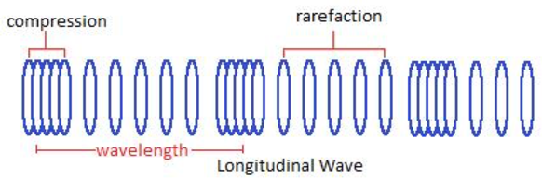 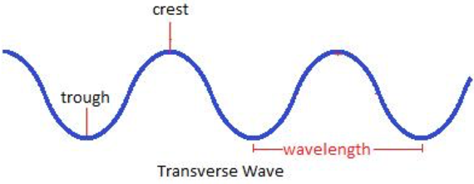

**Wave characteristics**

An area of compression and a neighbouring zone of rarefaction identify one cycle of an ultrasound wave. A wave cycle can be depicted as a graph of local pressure in the medium versus distance I along the direction of the wave (Figure 2.). The wavelength is the distance covered by one cycle. The number of cycles per unit time introduced in the medium each second is referred to as the frequency, and measured in unit of hertz, kilohertz or megahertz, where 1 Hz is 1 cycle per second. The maximum height of the wave cycle is referred to amplitude of the ultrasound wave. And the multiplication of the frequency and the wavelength is the velocity of the wave and expressed as below: